**CHAPTER 1**

**INTRODUCTION**

**1.1 Background**

Dyslexia is one of the most common learning disabilities worldwide, affecting approximately 5–15% of the population depending on language and orthographic depth. Children with dyslexia often face challenges in reading, writing, spelling, and sometimes even speaking. Early detection and tailored interventions are crucial for mitigating the long-term academic and emotional impacts of dyslexia.

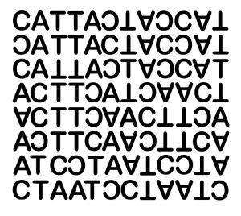

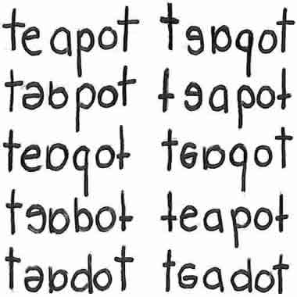

Fig 1.1 : Dyslexia Patient Vision

Traditional methods of diagnosing dyslexia involve expert evaluations, standardized tests, and behavioral observations often taking months and involving significant costs. With the advent of Artificial Intelligence (AI) and Machine Learning (ML), there is an opportunity to revolutionize early dyslexia detection by making it more accessible, faster, and cost-effective.

Moreover, children diagnosed with dyslexia require consistent and engaging learning support. Modern digital tools, especially game-based learning platforms, have shown tremendous promise in enhancing cognitive skills such as memory, phonological awareness, and typing accuracy, which are often weaker in dyslexic children.

**1.2 Project Overview**

This project proposes an AI-driven dyslexia detection system coupled with an interactive learning aid designed specifically for children aged between 5 and 8 years. The dual-module system aims to achieve two primary objectives:

* **Early Dyslexia Detection:**  
  Leveraging machine learning models to predict potential signs of dyslexia based on user interaction data collected through a web application developed with Streamlit.
* **Interactive Learning Aid:**  
  A set of ReactJS-based mini-games targeting specific cognitive and linguistic skills, designed to help dyslexic children enhance their reading, writing, and memory capabilities in an enjoyable and stress-free manner. The solution not only empowers parents and educators with a preliminary diagnostic tool but also provides continuous support for affected children through educational games.
  1. **Motivation**

The motivation behind this project stems from the need to bridge the gap between early diagnosis and effective intervention. Many dyslexic children are diagnosed late, losing critical developmental years. Early identification, followed by focused learning support, can significantly improve their educational trajectory. Additionally, gamified learning ensures that interventions are not perceived as burdensome but are instead engaging and motivating for young learners.

* **Addressing the Problem of Late Diagnosis**

Many children with dyslexia are not diagnosed until they have already started failing in reading and writing tasks, sometimes not until middle or high school. By this time, they may have

* Lost confidence in themselves.
* Fallen behind academically.
* Developed anxiety or behavioral issues related to schoolwork.
* This delay happens mainly due to
* Lack of awareness among parents and teachers.
* Limited access to experts or professional assessments.
* High cost and time commitment of traditional evaluation methods.
* **Bridging the Gap Between Diagnosis and Intervention**

Even when dyslexia is diagnosed, there's often a second gap: from diagnosis to effective intervention. children may not get the targeted support they need, or the methods used may not be engaging or personalized.

This project aims to bridge both of these gaps:

* By using AI/ML to detect dyslexia early through a simple, accessible interface.
* By offering game based learning tools that are fun, personalized, and effective.
* **Making Learning Support Engaging Through Gamification**

Young children often respond better to play based learning than traditional teaching methods. Instead of seeing exercises as a burden or punishment, they enjoy them when:

* They are presented as games.
* There is a reward system (like points, levels, or badges).
* The experience is interactive and colourful.

This approach is called gamification, and it’s a key motivational factor behind this project. It transforms learning from something stressful into something enjoyable especially important for children with learning difficulties.

* **Combining Technology with Psychology**

This project is not just about using AI or creating games it’s about combining:

* Artificial Intelligence (AI) for pattern recognition and prediction.
* Educational Psychology to understand how dyslexic children learn best.

By integrating these two fields, the project supports both early identification of learning issues and the long-term development of the child.

* **Holistic, Child-Centered Design**

The motivation is also rooted in the belief that every child learns differently. A one size fits all approach doesn't work, especially for children with dyslexia. This project:

* Observes how each child interacts with tasks.
* Adapts difficulty levels based on performance.
* Gives feedback that’s supportive, not judgmental.

This kind of personalized and inclusive design helps children learn at their own pace and feel confident doing so.

* **Real-World Impact**

Ultimately, the goal is to empower parents, teachers, and children with a practical tool that:

can be used at home or in schools.

* Doesn’t require deep technical knowledge to operate.
* Helps children gain foundational skills in reading, writing, memory, and phonics.
* This project can reduce dependency on expensive clinical assessments, and instead offer a scalable, affordable, and effective alternative for communities worldwide.

By using AI for detection and ReactJS-based games for support, this project demonstrates a holistic approach combining technological innovation with educational psychology principles.

**1.4 Objectives**

The primary objectives of this project include:

* Develop a Streamlit-based AI model capable of predicting dyslexia tendencies through interactive user tasks.
* Create a ReactJS frontend hosting memory, phonics, typing, and word building games targeted at improving key cognitive skills.
* Design a MySQL database system for securely storing user profiles, detection results, and game scores.
* Ensure seamless communication between frontend, backend, and database through APIs.
* Offer an inclusive, interactive, and personalized learning environment for children diagnosed or at risk of dyslexia.

**1.5 Scope of the Project**

This project focuses primarily on:

* Children aged 5 to 8 years, considering their critical period for reading development.
* Building a prototype-level system deployable locally, with future possibilities of cloud deployment.
* Creating an initial machine learning model trained on collected data rather than extensive external datasets.
* Designing interactive games that enhance the cognitive functions most impacted by dyslexia.
* Local deployment using XAMPP for database management and possible cloud deployment in future iterations.

**CHAPTER 2**

**LITERATURE SURVEY**

[1] Velmurugan S."Predicting Dyslexia with Machine Learning: A Comprehensive Review of Feature Selection, Algorithms, and Evaluation Metrics ". This literature review explores the use of machine learning-based approaches for the diagnosis and treatment of dyslexia, a learning disorder that aﬀects reading and spelling skills. Various machine learning models, such as artiﬁcial neural networks (ANNs), support vector machines (SVMs), and decision trees, have been used to classify individuals as either dyslexic or non-dyslexic based on functional magnetic resonance imaging (fMRI) and electroencephalography (EEG) data. These models have shown promising results for early detection and personalized treatment plans. However, further research is needed to validate these approaches and identify optimal features and models for dyslexia diagnosis and treatment.

[7] Alqahtani, N.D.; Alzahrani, B.; Ramzan, M.S. "Deep learning applications for dyslexia prediction". Appl. Sci. 2023, 13, 2804. <https://doi.org/10.3390/app13052804> Published: 22 February 2023. This review paper analysed the prediction performance of deep learning models for dyslexia and summarizes the challenges researchers face when they use deep learning models for classification and diagnosis. Using the PRISMA protocol, 19 articles were reviewed and analysed, with a focus on data acquisition, preprocessing, feature extraction, and the prediction model performance. The purpose of this review was to aid researchers in building a predictive model for dyslexia based on available dyslexia-related datasets. The paper demonstrated some challenges that researchers encounter in this field and must overcome.

[11] Yazeed Alkhurayyif, Abdul Rahaman Wahab Sait, "A Review of Artificial Intelligence-Based Dyslexia Detection Technique" Diagnostics 2024, 14(21),2362. <https://doi.org/10.3390/diagnostics14212362>, Published: 23 October 2024. The review findings revealed various DRTs for identifying critical dyslexia patterns from multiple modalities. A significant number of studies employed principal component analysis (PCA) for feature extraction and selection. The authors presented the essential features associated with DD. In addition, they outlined the challenges and limitations of existing DRTs. Impact: The authors emphasized the need for the development of novel DRTs and their seamless integration with advanced DL techniques for robust and interpretable DD models.

[12] S Santhiya and C S KanimozhiSelvi " A study on dyslexia detection using machine learning techniques for checklist, questionnaire and online game-based datasets". The proposed article presents methodologies and techniques used for detecting dyslexia. The primary contribution of this paper is a comparative analysis of various machine learning algorithms.

**CHAPTER 3**

**PROBLEM STATEMENT**

Dyslexia is a learning difficulty that affects a child's ability to read, write, and process language, often remaining undiagnosed due to a lack of accessible assessment tools. This project aims to develop an AI-driven system for detecting and assessing dyslexia in a specific age group, providing targeted learning support through gamification and multisensory techniques, including visual, auditory, and physical interactions. The system will dynamically adapt to each child's progress, offering a personalized learning experience that helps them overcome reading and cognitive challenges. Additionally, we will build a functional prototype that integrates these features, ensuring practical application and accessibility. By empowering educators, parents, and dyslexic children with a scientifically backed and interactive solution, this project aspires to enhance early detection, foster confidence, and support long-term learning success.

**CHAPTER 4**

**METHODOLOGY**

The project aims to develop an AI-driven system for detecting and assessing dyslexia in children within a specified age group. It focuses on providing an accessible diagnostic tool and a personalized learning aid. The system analyses cognitive, linguistic, and behavioural data to ensure early identification and intervention. A prototype will be built to integrate these capabilities into an interactive platform for educators and parents.

1. **Dataset Collection and Preparation**

Data collection is a critical component of the project, incorporating both public datasets, such as those from kaggle, and custom data gathered through collaborations with educational institutions. The collected data includes text samples, audio recordings, and behavioural metrics like eye movement and cursor tracking. Preprocessing techniques such as noise reduction, text normalization, and structured formatting are applied to enhance data quality.

The dataset is primarily generated through user interactions within the application, including:

* **Handwriting Analysis**: Typing patterns such as speed, accuracy, and error rate.
* **Reading Performance**: Phonological tasks where children identify sounds, letters, and basic words.
* **Memory Tasks**: Matching games testing short-term memory retention.
* **Phonological Awareness Tasks**: Activities assessing the ability to manipulate sounds within words.

1. Data Collection Mechanism

Data is collected passively during gameplay or explicitly during diagnostic tasks. Each interaction records parameters like:

* Time taken
* Accuracy rate
* Error frequency
* Response patterns

1. Data Preprocessing

The collected raw data is subjected to rigorous preprocessing to ensure that only clean and meaningful information is fed into the AI models.

Steps involved in preprocessing:

* Data Cleaning: Removal of incomplete or irrelevant entries.
* Feature Engineering: Extraction of meaningful features such as typing speed per word, phoneme recognition rate, etc.
* Numerical Vectorization: Textual and categorical data are converted into numerical formats for machine learning compatibility.
* Normalization and Standardization: Scaling features to a common range (e.g., 0-1) to avoid bias toward higher magnitude features.

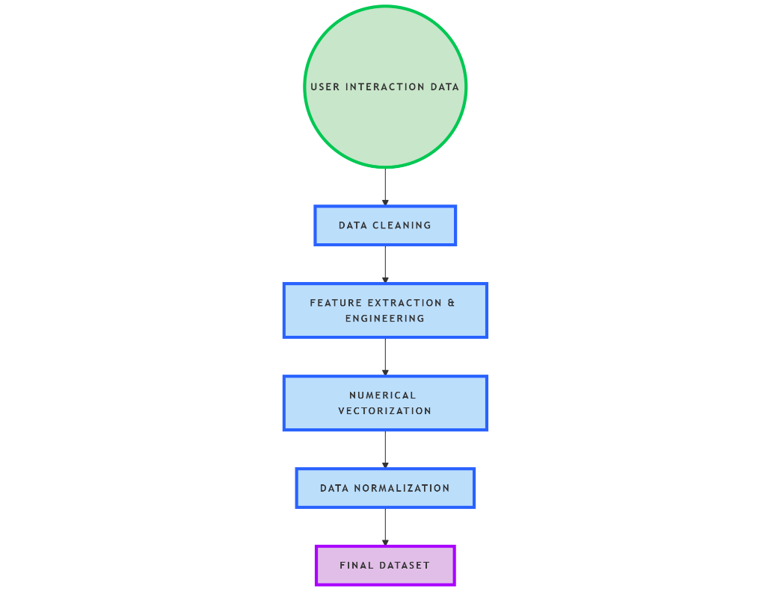

Fig 4.1.1: Steps of Data Preprocessing

1. **Model Training**

Once the data is pre-processed, it is used to train the machine learning models.

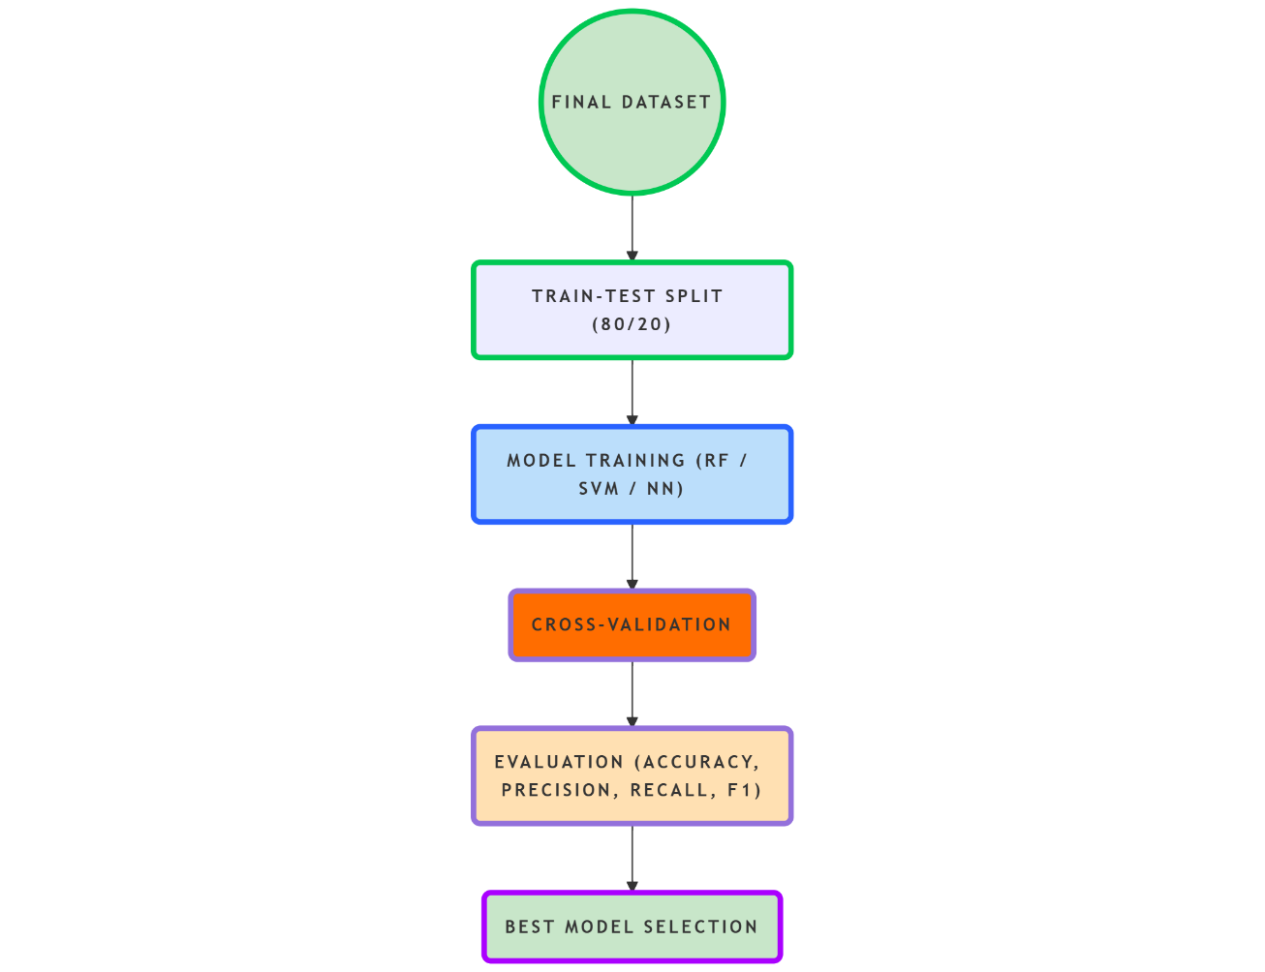

Fig 4.2.1: Model Training Flow Diagram

1. **Algorithms Used**

* Random Forest Classifier: An ensemble method that builds multiple decision trees and merges them to improve prediction accuracy and control overfitting.
* Support Vector Machines (SVM): A powerful classification technique used to find the hyperplane that best separates the classes.
* Lightweight Neural Networks: Small-scale neural networks trained for pattern recognition without heavy computational demands.

1. **Training Strategy**

* Train Test Split: The data is split into 80% training and 20% testing sets to validate the model performance.
* Cross-Validation: 5-Fold cross-validation is used to ensure the model's generalizability across unseen data.
* Evaluation Metrics:
  + 1. Accuracy: Overall correct predictions.
    2. Precision: How many predicted positives are actually positive.
    3. Recall: Ability to find all positive instances.
    4. F1-Score: Harmonic mean of precision and recall.

1. **Streamlit Integration**

To deliver an interactive and accessible user interface for both data collection and prediction display, the project utilizes Streamlit, a Python-based open-source framework. Streamlit simplifies the process of building web applications for machine learning and data science by offering straightforward and flexible component integration.

Features of the Streamlit Based Interface:

* Interactive Input Forms: These include text inputs, dropdown menus, sliders, and button-based prompts that collect user data during assessments and games. The interface is intuitive enough for young children, ensuring ease of use.
* Real-Time Preprocessing: As the child interacts with the platform, data is collected and processed in real time. This means cleaning, feature extraction, and formatting occur on the backend as the child performs tasks.
* Prediction and Feedback: After completing a set of tasks, the system uses the pre-trained AI model to classify the user's performance into risk levels such as "Low Risk," "Moderate Risk," or "High Risk" for dyslexia. This feedback is presented in a visually engaging format to maintain a child-friendly environment.
* Educational Insight Display: For parents and teachers, a separate section of the dashboard offers insights into specific areas of strength and weakness, based on AI predictions and gameplay analytics.

Streamlit’s simplicity enables rapid development and integration of backend AI models with the frontend interface. Moreover, it supports fast deployment in local or cloud environments, making it suitable for educational institutions and parents alike.

1. **Streamlit Application Insights:**

* Input Collection Forms: Text input fields, button interactions, timing mechanisms.
* Real-time Preprocessing: Data collected is pre-processed instantly within the app backend.
* Real Time Prediction Execution: The pre-trained AI model runs inference on the processed data.
* Result Display: Output is shown clearly indicating risk levels (e.g., "Low Risk", "Moderate Risk", "High Risk").

Fig 4.3.1: Detection Flow Diagram

1. **Personalized Learning Aid Development**

An interactive educational platform is developed to integrate the detection system with a personalized learning aid. the system continuously adapts learning activities based on the child's progress, ensuring effective engagement through gamification features such as points, rewards, and progressively challenging tasks. the platform provides real time feedback and detailed progress tracking, offering educators and parents insights into the child's development.

A key component of the proposed system is the development of a personalized educational platform that not only identifies children at risk of dyslexia but also supports their learning through interactive, gamified exercises. The learning aid is designed to adapt to each child’s performance and learning curve.

Design Principles:

* Gamification: Rewards, points, levels, and visual engagement elements are used to maintain interest and encourage repeated practice.
* Multisensory Learning: Tasks integrate visual, auditory, and motor skill activities to reinforce learning pathways.
* Real-Time Feedback: Children receive instant responses to their actions, which improves engagement and helps correct errors early.
* Adaptive Difficulty**:** The system gradually increases or decreases task complexity based on performance metrics.

1. **Overview of Learning Games**

The learning aid comprises four carefully designed games, each mapped to a key developmental area:

|  |  |  |
| --- | --- | --- |
| Games | Focus Area | Purpose |
| Memory Game | Working Memory | Improve information retention and recall |
| Phonics Game | Phonological Awareness | Strengthen sound-letter association |
| Typing Game | Typing Fluency | Enhance typing speed, accuracy, and motor skills |
| Word Building Game | Vocabulary and Spelling Skills | Expand vocabulary and support word formation |

1. **Detailed Game Description**
2. **Memory Game:**

The Memory Game is designed to enhance children's cognitive abilities, particularly focusing on working memory and concentration. In this engaging activity, a deck of shuffled cards is laid out face down, and the player is allowed to flip two cards at a time in an attempt to find matching pairs. If the selected cards match, they remain face-up; if not, they are turned face-down again. This process continues until all pairs are successfully matched, encouraging the player to remember the location and identity of previously revealed cards.

This simple yet effective game targets key developmental skills such as short-term memory, attention span, and visual recognition. As children play, they must focus intently to recall the position of cards they have seen before, promoting sustained concentration. The visual patterns and symbols on the cards also support the development of recognition and comparison skills. Overall, the Memory Game serves as both a fun and educational tool to boost mental agility in young learners.

Gameplay:

* A deck of shuffled cards is displayed face down.
* The child flips two cards per turn to find matching pairs.
* Matching cards remain revealed; non-matching cards are flipped back.
* The game ends when all pairs are matched.

Skills Targeted:

* Short-term memory
* Attention span
* Visual recognition

Fig 4.4.1: Steps for Memory game

1. **Phonics Game:**

This game is designed to improve phonological awareness by helping children associate spoken sounds with their corresponding letters. During gameplay, the child listens to a sound clip that plays a specific phoneme. After hearing the sound, multiple letter options are displayed on the screen. The task is to select the correct letter that matches the sound heard. This process not only reinforces sound-to-letter recognition but also engages the child's focus and auditory skills.

The primary skills targeted through this activity include sound-to-letter association, auditory processing, and early reading readiness. By repeatedly identifying the correct letters for various phonemes, children strengthen the neural pathways involved in language and reading. From a technical perspective, this game applies basic principles of pattern recognition and user interaction, aligning with structured learning objectives while maintaining user engagement.

Gameplay:

* The child listens to a sound clip (phoneme).
* Several letter options are displayed.
* The child selects the correct letter matching the sound.

Skills Targeted:

* Sound-to-letter association
* Auditory processing
* Early reading readiness

Fig 4.4.2: Steps for phonics game

1. **Typing Game:**

This game is developed to enhance typing speed and accuracy, which are essential for effective written communication. In the gameplay, a word is displayed on the screen, and the child is required to type the word into an input box as quickly and accurately as possible. The system provides immediate feedback on correctness, allowing the child to recognize and correct mistakes in real time. Additionally, the game records typing speed and error rate, helping to track progress and identify areas that need improvement.

The targeted skills include fine motor coordination, typing fluency, and orthographic processing. Fine motor coordination is improved as the child repeatedly uses the keyboard, while typing fluency develops with regular practice and feedback. Orthographic processing, the ability to recognize written word patterns, is also strengthened, contributing to better spelling and reading abilities. From a technical standpoint, the game involves real-time input handling and performance tracking, making it an interactive and educational tool suitable for early learners.

Gameplay:

* A word is displayed.
* The child types the word into an input box as quickly and accurately as possible.
* Immediate feedback on correctness is given.
* Typing speed and error rate are recorded.

Skills Targeted:

* Fine motor coordination
* Typing fluency
* Orthographic processing

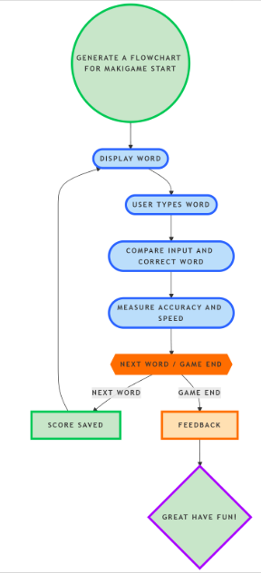

Fig 4.4.3: Steps For Typing Game

1. **Word Building Game:**

This game is designed to develop vocabulary and spelling skills by engaging children in word formation challenges. In the gameplay, a jumbled set of letters is displayed on the screen, and the child must rearrange them to form a meaningful word. If the child struggles to find the correct answer after several attempts, the game can provide hints to guide them. This interactive format helps maintain interest while reinforcing language skills.

The main skills targeted include vocabulary expansion, spelling accuracy, and logical thinking. By forming correct words from scrambled letters, children are exposed to new vocabulary and improve their spelling through repetition and recognition. Additionally, the process of logically analyzing letter combinations to create valid words enhances their cognitive and problem-solving abilities. This game combines educational value with engaging mechanics, making it a practical tool for language development in early learners.

Gameplay:

* A jumbled set of letters is displayed.
* The child arranges letters in the correct order to form a meaningful word.
* Hints may be provided after multiple wrong attempts.

Skills Targeted:

* Vocabulary expansion
* Spelling accuracy
* Logical thinking

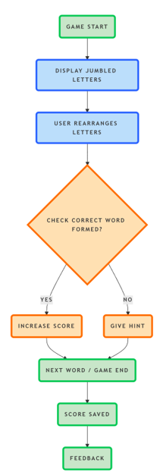

Fig No 4.4.4: Steps for world building game

* 1. **Continuous Improvement**

Continuous improvement is ensured through performance monitoring, with dashboards displaying progress trends and behavioural insights. Adaptive learning paths help refine interventions, keeping the experience engaging and effective. This AI-powered approach bridges the gap between dyslexia diagnosis and tailored educational support, fostering confidence and long-term learning success for affected children.

**CHAPTER 5**

**RESULTS AND DISCUSSIONS**

Our dyslexia detection tool is an innovative, AI-powered platform designed to assist children in overcoming the challenges of dyslexia. by combining advanced machine learning techniques with interactive, game-based assessments, we offer a simple and engaging way to detect early signs of dyslexia. our goal is to make early intervention accessible, effective, and enjoyable, giving every child a fair chance to thrive academically and emotionally.

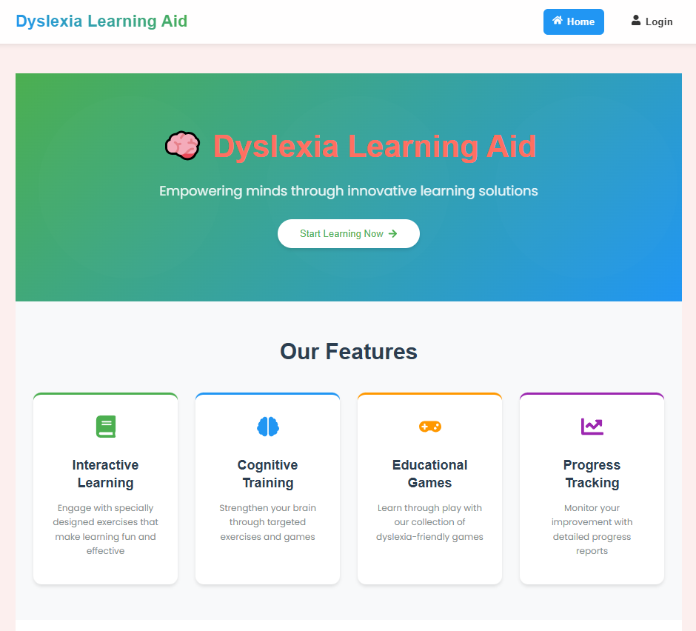

Fig 5.1.1: Landing page of the project

Beyond detection, our tool provides a personalized learning journey through carefully designed educational games that strengthen essential skills such as memory, phonics, vocabulary, and fluency. With real-time feedback, progress tracking, and child-friendly visuals, our platform supports each learner’s unique pace and needs. Whether you are a parent, educator, or therapist, our tool equips you with the tools to support children in a meaningful, data-driven, and nurturing environment.

Fig 5.1.2: Login page for the user

Welcome to the Dyslexia Learning Aid platform your first step toward personalized learning and early dyslexia support. Log in to access engaging games, track progress, and receive insights tailored to your child’s needs. Whether you are a parent, teacher, or young learner, our secure login ensures a safe and supportive learning journey every time you sign in.

this user profile dashboard offers a comprehensive overview of a child's assessment results within the dyslexia learning aid platform. displaying essential personal details such as username and dyslexia risk level, it indicates that the user “Sayeed” has been identified with a moderate dyslexia risk based on a combined quiz and survey score. the dashboard visualizes performance across key cognitive areas—memory, speed, visual, audio, language, and more—highlighting strengths and areas needing support. for instance, strong auditory performance contrasts with weaknesses in visual and language skills. accompanying recommendations guide parents and educators with actionable steps such as scheduling expert assessments, implementing literacy interventions, and personalizing learning plans. this interface empowers users with clear, data-driven insights to support the learner’s progress effectively.

Fig 5.1.3: Profile Page Showing the Pre-Assessment Result

The dyslexia learning aid platform features four engaging and purpose-driven games, each designed to target a key developmental area commonly affected by dyslexia. in the memory game, children are presented with a grid of face-down cards and must flip two at a time to find matching pairs. this game helps strengthen short-term memory, concentration, and visual recognition by encouraging children to remember card positions and recall them accurately. the phonics game builds phonological awareness by playing a sound (phoneme) and asking the child to select the correct corresponding letter or word from several choices. this reinforces the vital connection between sounds and symbols, improving early reading skills and auditory processing. in the typing game, children are shown a word on-screen and must type it as quickly and accurately as possible into an input field. the game tracks typing speed and highlights errors, promoting fine motor skills, spelling accuracy, and fluency in written communication. lastly, the word building game presents jumbled letters that children must rearrange to form a correct word. hints become available after a few incorrect attempts, guiding the child to think critically about letter order and word formation. together, these games offer a multisensory, interactive learning experience that adapts to each child's pace and progress, making foundational skill-building both effective and enjoyable.

Fig 5.1.4: Phonological Awareness Game

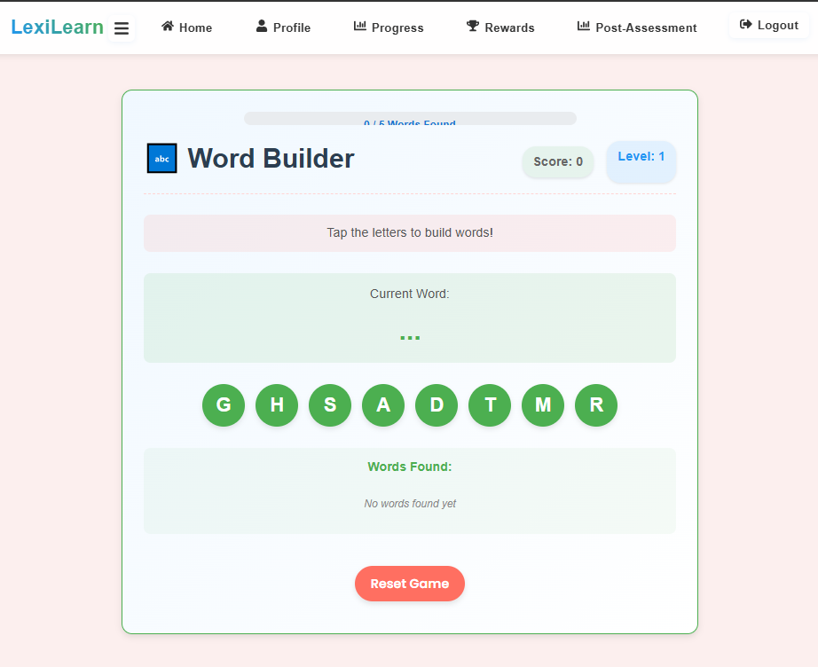

Fig 5.1.5: World Builder Game

Fig 5.1.6: Working Memory Game

Fig 5.1.7: Letter Matching Game

This rewards and badges dashboard showcases a motivating and progress-oriented learning environment designed to celebrate each child’s achievements throughout their dyslexia support journey. as children engage with various educational games like sound bubbles, word builders, phonological awareness, and fast tap challenge they earn points and unlock badges that recognize their efforts and improvement in key skill areas. each category includes multiple badge tiers (e.g., sound explorer, sound wizard, memory genius) to encourage continued growth and mastery. The visual progress bars and gamified milestones provide instant feedback, reinforcing a sense of accomplishment and motivating children to keep learning. Additionally, helpful tips at the bottom guide users on how to earn more badges, such as playing consistently, aiming for higher difficulty levels, and practicing pronunciation. This feature transforms learning into a rewarding adventure, turning practice into progress in a fun and empowering way.

Fig 5.1.8: Dashboard Showing earned badges by the user

Post-Assessment Quiz section of the Dyslexia Learning Aid application. The first image presents a detailed result analysis, comparing the user’s previous and current assessment scores through a bar chart showing a significant improvement from 12/40 to 32/40. It also includes insights on dyslexia risk (71.2%), severity level (moderate dyslexia), and provides targeted recommendations for further learning support. The second image displays the interactive quiz interface, featuring a mix of visual and auditory questions tailored to assess various aspects of learning and recognition. Questions include alphabet identification, image and sound recognition, and spatial awareness, ensuring a multi-sensory approach to evaluating the user’s progress.

Fig 5.1.9: Post Assessment quiz result

**CHAPTER 6**

**CONCLUSION AND FUTURE SCOPE**

1. **Conclusion**

This project presents a comprehensive approach to addressing one of the most common yet underdiagnosed learning disabilities—dyslexia—by integrating modern technology with educational psychology. By designing a two-fold system comprising an AI-driven detection module and a personalized learning aid, this initiative has laid the groundwork for an innovative and accessible solution to early dyslexia identification and intervention. The AI detection system focuses on analysing behavioral, cognitive, and linguistic data collected through interactive tasks embedded in a child-friendly web application. Meanwhile, the learning aid component utilizes gamification and multisensory learning strategies to provide tailored support in key developmental areas such as memory, phonological awareness, vocabulary, and motor coordination. Although the system is still in its early development phase, foundational components such as the user interface, data collection modules, and the basic infrastructure for AI integration have been implemented successfully.

1. **Future Scope**

The future of this project holds vast potential. Enhancements will focus on integrating real-world data for model training, expanding accessibility through mobile compatibility, and deploying the system on cloud platforms. Additionally, the inclusion of speech-based inputs and adaptive learning features will improve support for a wider range of users. Collaborations with schools and therapists will further validate and refine the system, promoting its adoption in early education and intervention programs.

**REFERENCES**

1. Predicting Dyslexia with Machine Learning: A Comprehensive Review of Feature Selection, Algorithms, and Evaluation Metrics" by Velmurugan S[.](https://www.researchgate.net/publication/372732512_Predicting_Dyslexia_with_Machine_Learning_A_Comprehensive_Review_of_Feature_Selection_Algorithms_and_Evaluation_Metrics)
2. "A Systematic Review of Research Dimensions Towards Dyslexia Screening Using Machine Learning" by Tabassum Gull Jan and Sajad Mohammad Khan.
3. "Early Detection of Dyslexia, Dyscalculia, Dyspraxia, Dysgraphia Using Machine Learning" by Aditi Chakraborty et al.
4. "A Study on Dyslexia Detection Using Machine Learning Techniques for Checklist, Questionnaire, and Online Game-Based Datasets" by S. Santhiya and C.S. KanimozhiSelvi.
5. Yuzaidey, N.A.M.; Din, N.C.; Ahmad, M.; Ibrahim, N.; Razak, R.A.; Harun, D. Interventions for children with dyslexia: A review on current intervention methods. Med. J. Malays. 2018, 73, 311–320.
6. Kaisar, S. Developmental dyslexia detection using machine learning techniques: A survey. ICT Express 2020, 6, 181–184.
7. Alqahtani, N.D.; Alzahrani, B.; Ramzan, M.S. Deep learning applications for dyslexia pre-diction. Appl. Sci. 2023, 13, 2804.
8. Usman, O.L.; Muniyandi, R.C.; Omar, K.; Mohamad, M. Advance Machine Learning Methods for Dyslexia Biomarker Detection: A Review of Implementation Details and Challenges. IEEE Access 2021, 9, 36879–36897.
9. Poornappriya, T.S.; Gopinath, R. Application of machine learning techniques for improving learning disabilities. Int. J. Electr. Eng. Technol. 2020, 11, 392–402.
10. Liyakathunisa; Alhawas, N.; Alsaeedi, A. Early prediction of dyslexia risk factors in kids through machine learning techniques. In Kids Cybersecurity Using Computational Intelligence Techniques; Kacprzyk, J., Ed.; Springer: Cham, Switzerland, 2023; pp. 225–242.
11. Alkhurayyif, Y., & Sait, A. R. W. (2024). A review of artificial intelligence-based dyslexia detection techniques. Diagnostics, 14(21), 2362. <https://doi.org/10.3390/diagnostics14212362>
12. Santhiya, S., & KanimozhiSelvi, C. S. (2023). A study on dyslexia detection using machine learning techniques for checklist, questionnaire, and online game-based datasets. International Journal of Computer Applications, 175(2), 45–51.